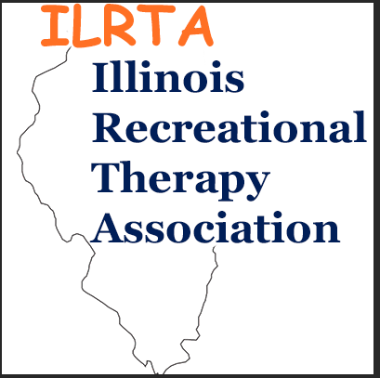
Session Proposal for
2022 ILRTA Conference
November 14-15, 2022
DoubleTree Hotel Chicago/Alsip
5000 W. 127th Street, Alsip, IL 60803

1. Title of Session: Must be descriptive of content and limited to twenty words; Related to NCTRC Job Analysis

2. Speaker Information: Name of speaker as it should appear in the program, include all credentials

Name:

Title:

Agency:
Mailing Address:

City, State & Zip:

Daytime Phone Cell Phone Evening Phone

E-Mail Address

Co-Speaker:

Name:

Title:

Agency:
Mailing Address:

City, State & Zip:

Daytime Phone Cell Phone Evening Phone

E-Mail Address

1. Session Title: Must be descriptive of the content and limited to twenty words; Related to NCTRC Job Analysis (please use the term Recreation Therapy / Therapeutic Recreation if possible)

2. Session Description: Must be descriptive of the session, and limited to 150 words. Related to the NCTRC Job Analysis ; should specifically describe how the content relates to TR Practice.
If your proposal is accepted this is the description that will appear in the program.

3. Speaker Qualifications: Maximum of two page vitae or resume OR a 400 word biographical sketch (briefer bios and references are not acceptable) Describe qualifications to present this topic.
Vitae or Bio must be included with submission

4. Instructional Methods: Instructional methods used: (e.g., lecture, discussion, interactive, debate, panel, experiential, etc.)

5. Learning Outcomes: Provide measurable outcomes for each session: Related to NCTRC Job Analysis.

Examples of acceptable learning outcomes below:
Upon completion of session participants will:
- Identify three benefits of performing evidence – based TR practice
- Perform an internet search for a clinical question relating to TR practice
- Provide an example of using evidence - based practice in daily TR service delivery

Upon completion of this session participants will:
- Demonstrate understanding of three strategies that have occurred, to address TR public policy
- Identify at least three strategies they can initiate to affect public policy and the TR profession in their local area, the state and at the national level
- Identify three areas of where we need to go in the future for Therapeutic Recreation as it relates to Federal Public Policy in a changing environment

Examples of unacceptable learning outcomes:
Participants will:
- Improve knowledge of the topic
- Understand public policy
- Gain an understanding of the dementia practice guidelines
- Participate in discussion
- Learn how to have fun

6. Session Outline: Provide a detailed session outline of content and methodology:
Example below:
- Introduction of presenter (5 minutes)
- Short quiz (5 Minutes)
- Discussion about quiz (5 minutes)
- Self-determination theory (brief overview) (15 minutes)
- Autonomy-supportive environment vs. a controlled environment (20 minutes)
- Autonomy-supportive environment techniques (10 minutes)
- Break into groups to discuss how to relate to their agency/population (20 minutes)
- Wrap up and evaluation (10 minutes)

7. NCTRC Job Analysis Areas: Check one or two most prominent content areas for this session.

 Foundational Knowledge |  Assessment Process |  Documentation |  Implementation |  Administration of TR/RT Service |  Advancement of the Profession
Theories and Concepts | Selections and Implementation of Assessment | Individualized Intervention Plan | Selection of Programs | Personnel/Intern/  Volunteer Management | Professionalism
Practice Guidelines | Assessment Domains | Discharge/  Transition Plan | Modalities and/or Interventions | Budgeting/Fiscal Management | Credential Maintenance/  Professional Competencies
Diagnostic Groupings |  |  |  |  | PR/Promotion/  Marketing

8. Skill Level: Please circle: Student Entry Level Intermediate Advanced.

9. Length of Presentation: Please circle: 60 mins or 90 mins

10. Audio-Visual Equipment Needs: A corded microphone will be provided in each room. Please check the audio-visual equipment that will be required for your presentation.

___ Laptop Computer ___ Projector for Power Point

11. Room Style: Rooms will be set theater style (in rows) or class room style (with tables). Please note if open space is needed for an activity, please indicate this on your proposal.

Please submit Conference Session Proposal forms to:

BY E-MAIL: dorilrta@yahoo.com and kctrofh@yahoo.com

For questions, e-mail, or call 708-687-4396 Office / 708-638-5814 Cell

RETURN PROPOSAL BY: June 25, 2022

Thank you in advance for your interest in the 2022 ILRTA Conference.

